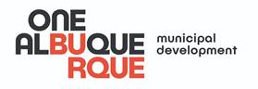 | FOR IMMEDIATE RELEASE  Contact: Johnny Chandler | 505-331-7729  May 5, 2020

Mayor Keller, Dave and Buster’s Partner to Say ‘Thank You’ to Essential Workers with Free Family Meals for our Streets Workers
Food for essential workers in the Department of Municipal Development donated by the restaurant, served using COVID Safe Practices to Families
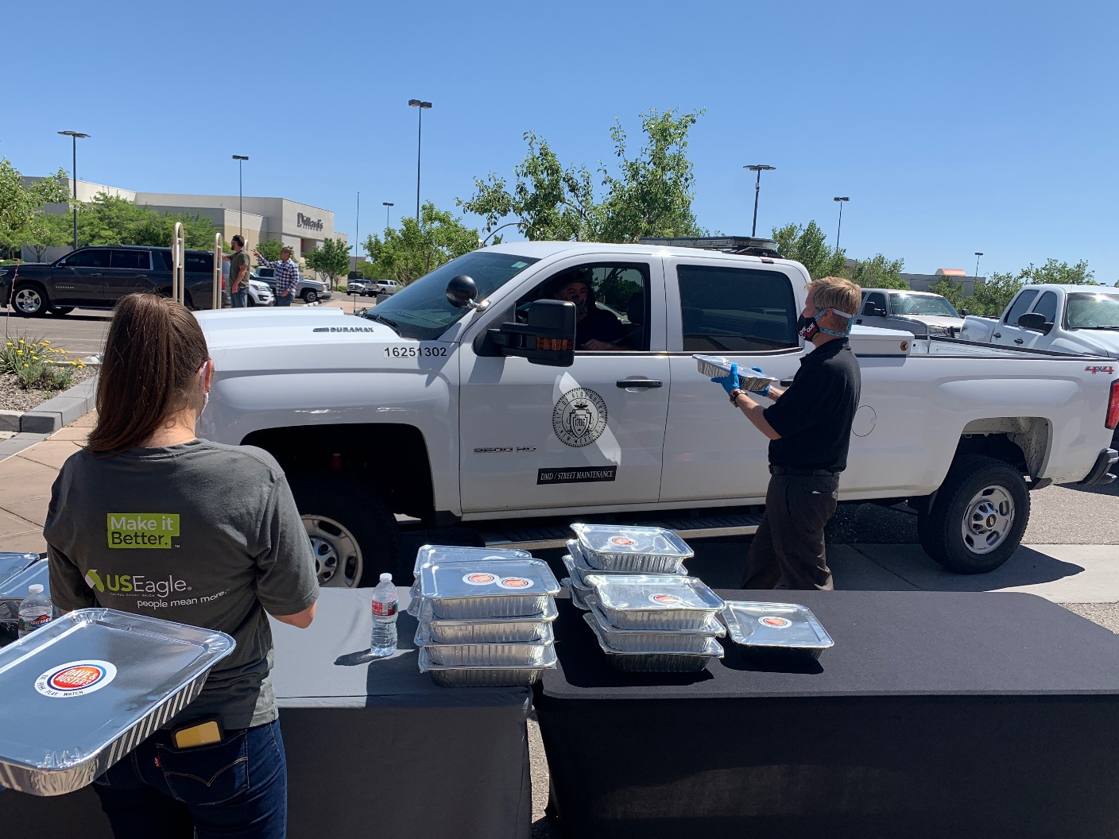

ALBUQUERQUE, N.M. – Since the first New Mexico case of COVID-19, hundreds of Albuquerque businesses have stepped up for the community, making masks and hand sanitizer, donating materials, or providing food to first responders and essential workers who are still hard at work serving the city. Now the locally-owned franchise of the popular Dave and Buster’s restaurant is joining the movement, pitching in to recognize the hard work the essential crews in the Department of Municipal Development (DMD) Street Maintenance Division are putting in to improve our streets.

Mayor Tim Keller and the Department of Municipal Development (DMD) Director Pat Montoya joined forces today with Dave and Buster’s to acknowledge the continued hard work the city street maintenance division team is doing during this crisis.

“While traffic is low and the economy is hurting, keeping construction going on our streets is critical work for our city’s infrastructure and recovery. These workers improving our roadways don’t have the option to stay home, so we’re saying thank you today to show how much we appreciate their dedication,” said Mayor Tim Keller.

DMD Street Maintenance workers are responsible for everything in the public right of way in the City of Albuquerque. Duties include fixing potholes, rehabilitating roadways, street sweeping, curb repair, maintaining our water detention ponds, and cleaning illegal dumping on public property.

DMD Director Pat Montoya said, “Our workers are on the streets everyday making your roadways better for all types of transportation, whether you walk, bike, or drive. Thank you to Dave and Buster’s for recognizing the city employees who can’t work from home.”

Dave and Buster’s safely served 70 family-size meals to essential workers.

“We look forward to serving families again with good food and entertainment in the near future,” said Dave and Buster’s General Manager Darien Kapture. “Until then we are happy to recognize the men and women who are making our streets better during this time and every day.”

US Eagle Federal Credit Union and 610theSportsAnimal’s ABQCentral with Fred Slow and Van Nunley helped organize the event.

###

